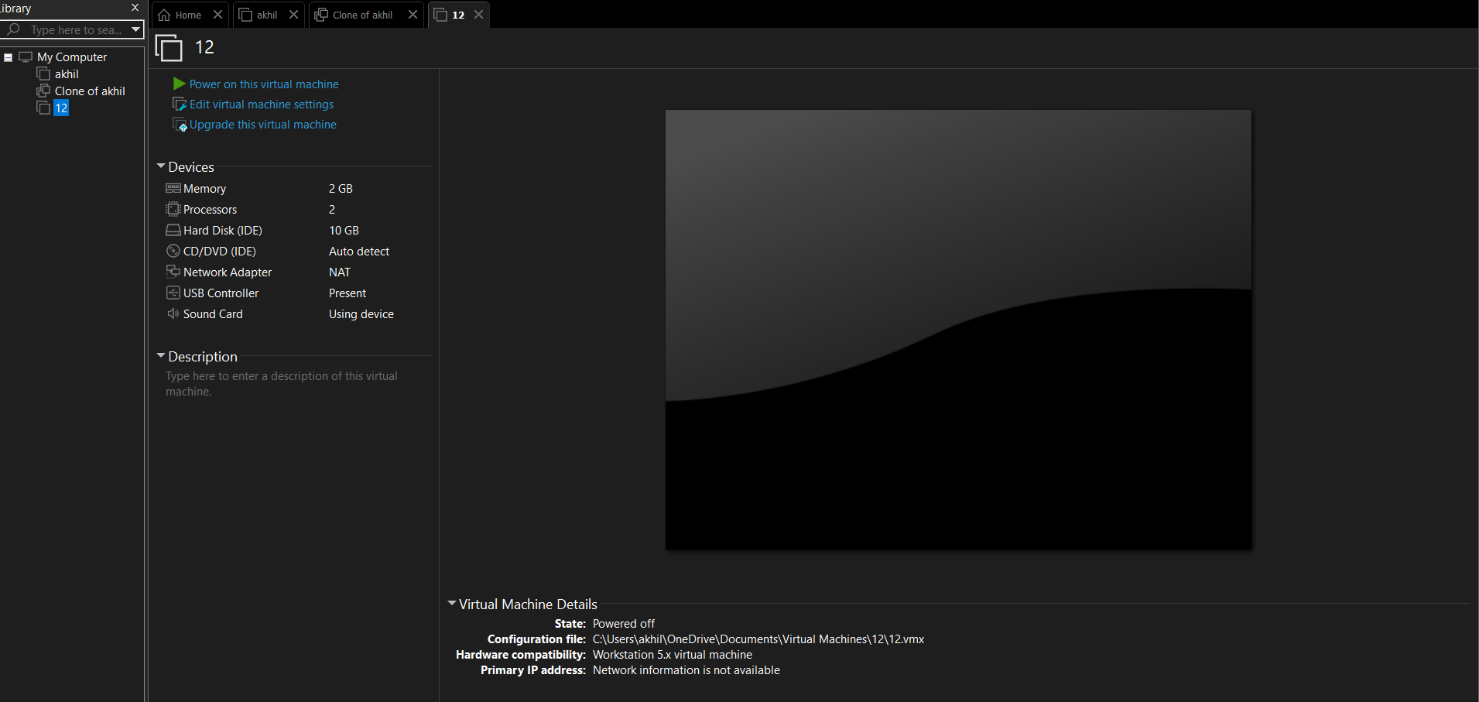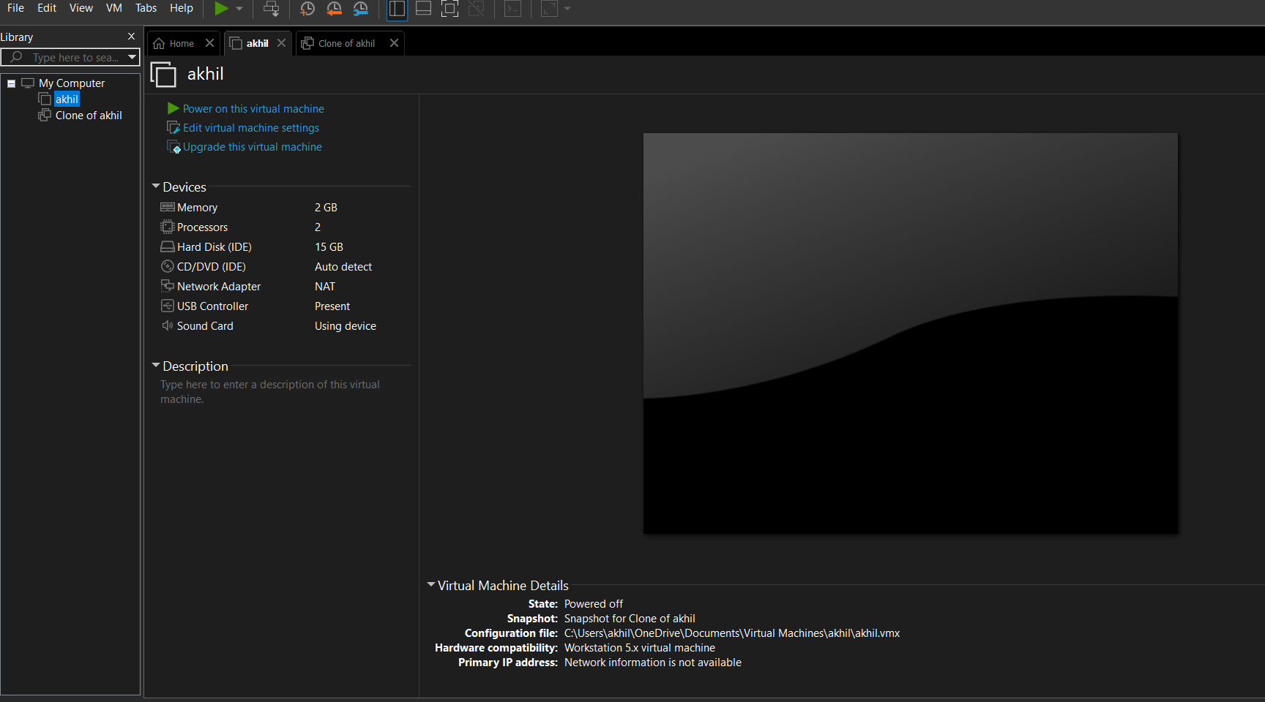creating the vm for 10gb

Creating a vm using 2gb ram and 15gb and 1 cpu

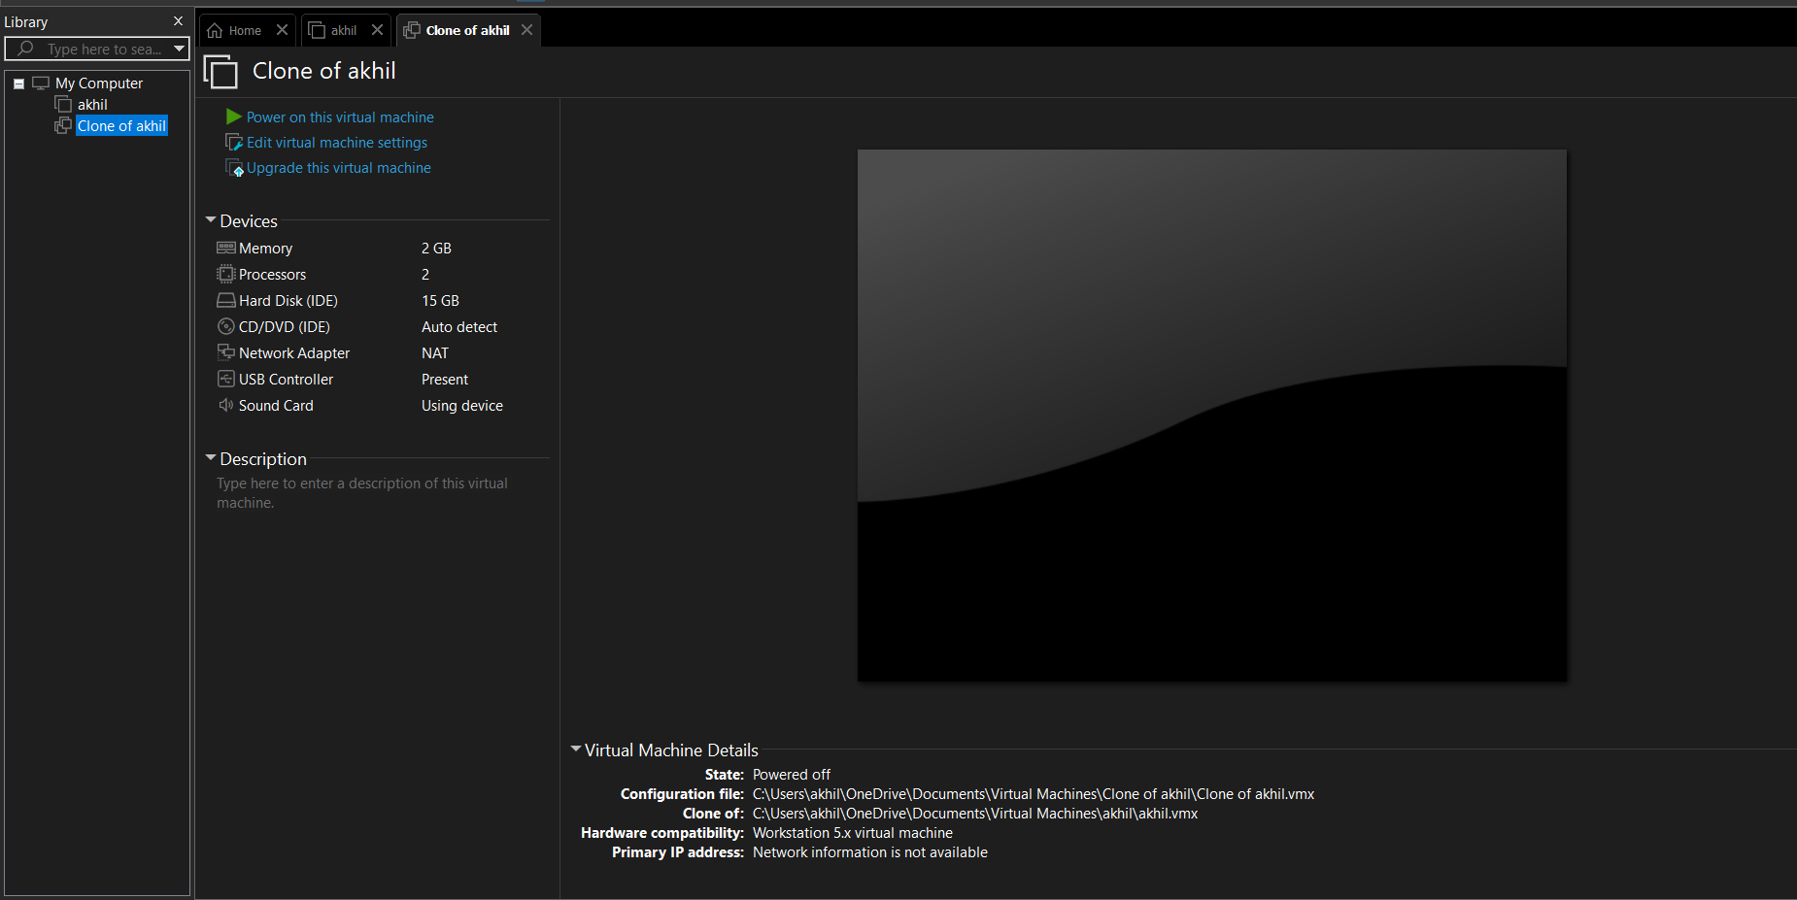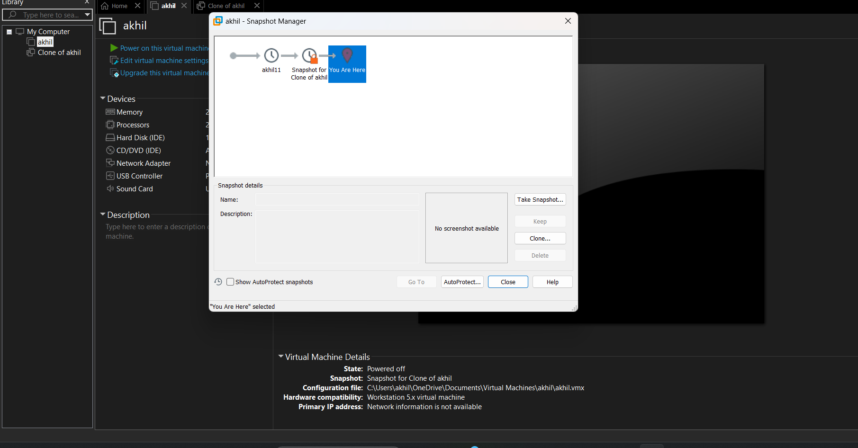CLONING IN THE VM WORK STATION

Sanpshot of the vm worksration

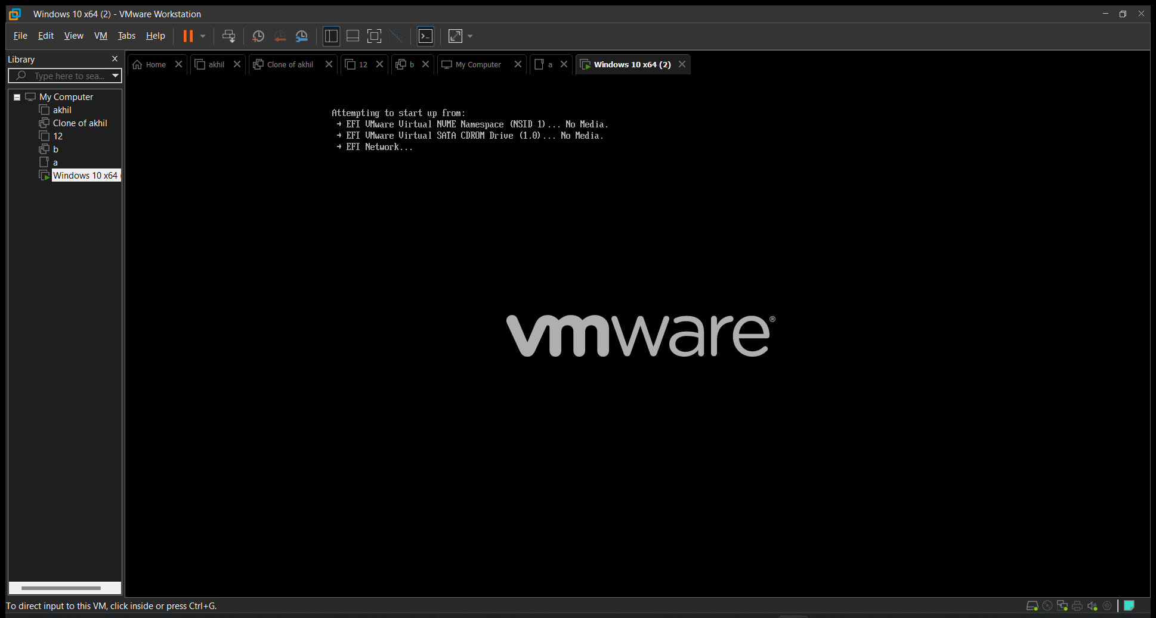creating the vm workstation